PROJECT TITLE
IPL Auction Team Selection Using Optimization Algorithms
A CAPSTONE PROJECT REPORT
A Capstone Project Report submitted in partial fulfilment of the requirements for the course
CSA-0603 Design And Analysis Of Algorithms
to the award of the degree of
BACHELOR OF TECHNOLOGY IN CSE/ARTIFICIAL INTELLEGENCE & DATA SCIENCE
Submitted by
CH.V.Rama Yogi(192424319)
D.Hussainaiah(192425300)
K.Subramanyam(192411253)
A.Velmurugan(192521074)
Under the Supervision of
Dr. P. Solainayagi
SIMATS ENGINEERING
Saveetha Institute of Medical and Technical Sciences
Chennai – 602105
SEPTEMBER 2026

SIMATS ENGINEERING
Saveetha Institute of Medical and Technical Sciences Chennai-602105

BONAFIDE CERTIFICATE

This is to certify that the Capstone Project entitled “IPL Auction Team Selection Using Optimization Algorithms” has been carried out by CH.V.Ramayogi (192424319) D.Hussainaiah(192425300) , K.Subramanyam(192411253), A.Velmurugan(192521074) under the supervision of Dr. P. Solainayagi and is submitted in partial fulfilment of the requirements for the current semester of the B.Tech CSE/AIDS program at Saveetha Institute of Medical and Technical Sciences, Chennai.

COURSE COORDINATOR COURSE FACULTY
Dr.F.Mary Harlin Fernandez Dr. P. Solainayagi
Professor Professor
Department Of CSE Department Of CSE
SIMATS Engineering, SIMATS Engineering,
SIMATS, Chennai – 602105. SIMATS, Chennai – 602105.

SIMATS ENGINEERING
Saveetha Institute of Medical and Technical Sciences Chennai-602105

DECLARATION

I, Ch.Venkata Ramayogi, D.Hussainaiah, K.Subramanyam , A.Velmurugan of the Department of CSE/AIDS, SIMATS Engineering, Saveetha Institute of Medical and Technical Sciences, Chennai, hereby declare that the Capstone Project Work entitled “IPL Auction Team Selection Using Optimization Algorithms” is the result of my own bonafide efforts. The work presented herein is original and has been carried out in accordance with engineering ethics and academic integrity. All sources, references, data, software resources, datasets, and AI-assisted resources used in the project have been appropriately acknowledged. The data, results, analysis, and findings have not been fabricated, falsified, or manipulated.
Place: Chennai
Date: September 2026

Signature of the Students with Names
Ch.Venkata Ramayogi
D.Hussainaiah,
K.Subramanyam ,
A.Velmurugan

INDIVIDUAL CONTRIBUTION STATEMENT
Student / Reg. No. | Responsibilities | Design & Development | Testing & Analysis | Report Contribution | %
Ch. Venkata Ramayogi / 192424319 | System architecture, frontend and integration | UI, architecture, integration | System testing | Chapters, diagrams | 40%

ABSTRACT
IPL auctions require teams to select players while balancing a limited purse, player performance, squad composition and auction constraints. This project proposes a web-based IPL Auction Team Selection system using Design and Analysis of Algorithms (DAA) optimization techniques. The system manages players, teams, auction bidding, budgets and squad composition through a responsive interface. The core optimization engine applies the 0/1 Knapsack algorithm to maximize overall team performance within a given budget, while a Greedy algorithm provides a fast heuristic for player selection. Sorting and Priority Queue techniques support player ranking and live bidding operations. The application provides team recommendations, Playing XI selection, auction history, budget analytics and performance dashboards. Testing is performed using controlled IPL-style player datasets and simulated auction scenarios. The expected outcome is an efficient and transparent decision-support system that reduces manual effort and demonstrates practical optimization algorithms in a real-world sports management problem.
Keywords: IPL Auction, Optimization Algorithms, 0/1 Knapsack, Greedy Algorithm, Dynamic Programming, DAA, Team Selection, Budget Optimization, Web Application

TABLE OF CONTENTS
Sl. No. | Title | Page  No
i | Certificate from the Supervisor | ii
ii | Declaration by the Candidate | iii
iii | Individual Contribution Statement | iv
iv | Abstract | v
v | List of Figures | vi
vi | List of Tables | vii
vii | List of Abbreviations / Symbols | viii
1 | Chapter 1: Introduction and Engineering Problem | 9-10
2 | Chapter 2: Literature Review and Existing Solutions | 11-12
3 | Chapter 3: Engineering Design & Trade-offs, Sustainability, Ethics, Safety, Risk & Security | 13-17
4 | Chapter 4: Implementation, Testing & Results, Project Management | 18-25
5 | Chapter 5: Conclusion, Future Work and Reflection | 26-27
 | References | 28
 | Appendices | 29-31

LIST OF FIGURES
Figure No. | Figure Name | Page No.
Figure 3.1 | Overall System Architecture | 15
Figure 3.2 | Auction and Bidding Flow | 15
Figure 3.3 | Optimization Process Flow | 15
Figure 3.4 | Team Recommendation Flow | 16
Figure 4.1 | Web Application Dashboard | 18
Figure 4.2 | Live Auction Interface | 23
Figure 4.3 | Optimized Team Recommendation | 23
Figure 4.4 | Analytics Dashboard | 24

LIST OF TABLES
Table No. | Table Name | Page No.
2.1 | Review of Existing Work | 11
2.2 | Comparative Analysis | 11-12
3.1 | Stakeholder / User Requirements | 13
3.2 | Functional and Non-Functional Requirements | 14
3.3 | Constraints and Applicable Standards | 14
3.4 | Design Specifications | 15
3.5 | Alternative Solution Evaluation | 17
3.6 | Trade-off Analysis | 17
3.7 | Sustainability, Ethics, Safety and Security | 18
3.8 | Risk Register | 18
4.1 | Software and Development Resources | 19
4.2 | Test Plan | 20
4.3 | Verification Results | 20
4.4 | Objective Achievement | 22
4.5 | Project Roles | 23
4.6 | Project Cost Estimate | 23

LIST OF ABBREVIATIONS / SYMBOLS
Symbol | Description | Meaning
DAA | Design and Analysis of Algorithms | Algorithm design and complexity analysis
IPL | Indian Premier League | Professional cricket league
DP | Dynamic Programming | Optimization technique
API | Application Programming Interface | Software communication interface
UI | User Interface | Application interaction layer
DB | Database | Persistent relational storage
XI | Playing XI | Selected eleven players

CHAPTER 1
INTRODUCTION AND ENGINEERING PROBLEM

1.1 Background
An IPL auction is a constrained decision-making process in which teams compete for players while working within a fixed purse and squad rules. Selecting players manually becomes difficult when many candidates have different prices, roles and performance levels. An algorithmic system can model player selection as an optimization problem and recommend a high-value squad while respecting budget and composition constraints.

1.2 Need for the Project
- Manual player selection can take more time when many players are available.
- Teams must balance player performance, cost and role requirements simultaneously.
- A large player pool creates many possible squad combinations that are difficult to compare manually.
- Team owners need quick access to player statistics, price and auction status.
- Optimization provides systematic and repeatable team-selection decisions.
- The project combines a responsive web interface, Flask backend, MySQL database and DAA optimization engine.

1.3 Problem Statement
IPL auction team selection is difficult because many players have different prices, roles and performance values, while teams must stay within a fixed purse and satisfy squad constraints. The engineering problem is to design and implement a system that manages auction activity and uses optimization algorithms to select a high-performance, balanced squad without exceeding the available budget.

1.4 Project Aim
To design and implement a reliable web-based IPL auction team-selection system that uses optimization algorithms to recommend a high-performance squad and Playing XI within budget and configured squad constraints.

1.5 Project Objectives
- To design a web-based IPL auction management system with a structured database and clear user roles.
- To implement player search, filtering, sorting and performance-based ranking.
- To implement secure team, player, budget and auction data management.
- To validate bids, prevent invalid purchases and maintain consistent squad and purse information.
- To generate optimized squad recommendations, Playing XI suggestions, auction history and analytics reports.
- To test optimization and auction operations using controlled IPL-style player datasets and simulated auction scenarios.

1.6 Scope
- Includes player ID, name, role, nationality, base price, current bid and performance statistics.
- Includes Player Management, Auction Management, Team Optimization and Dashboard & Analytics.
- Uses MySQL for normalized persistent storage of users, teams, players, auctions, bids, squads and analytics.
- Large-scale commercial deployment, continuously changing real-world IPL feeds and advanced predictive analytics are outside the academic prototype scope.
- Assumes valid player data, authenticated users and configured auction rules and constraints.

1.7 Expected Engineering Outcome
The intended outcome is a working prototype that demonstrates DAA optimization through a real-time auction interface, valid budget-aware squad recommendations, Playing XI selection, team analytics and functional validation.

CHAPTER 2
LITERATURE REVIEW AND EXISTING SOLUTIONS

2.1 Review Method
The review was organized around recent work in IPL player valuation, sports analytics, squad optimization, multi-objective optimization and auction strategy. These studies provide methods for measuring player value and constructing balanced squads.
2.2 Review of Existing Work
Author & Year | Title / Study | Methodology | Advantages | Disadvantages
Malhotra (2022) | Predicting IPL Auction Prices and Player Value | Player valuation and data analysis | Supports objective player valuation | Does not directly optimize a complete squad
Verma et al. (2022) | A Balanced Squad for Indian Premier League using Modified NSGA-II | Multi-objective evolutionary optimization | Balances multiple squad objectives | Higher computational complexity
Dey et al. (2024) | Optimising IPL Squad Composition | Mathematical optimization framework | Models budget and squad constraints | Depends on chosen performance metrics
Dave & Patel (2025) | Multi-Objective Optimization for IPL Team Selection | Real-binary optimization | Supports balanced team construction | Sensitive to selected indicators
Joglekar et al. (2025) | Clustered Auction Strategies and Performance Outcomes | Clustering and sports analytics | Provides auction strategy insights | Focuses more on analysis than automated optimization

2.3 Comparative Analysis
Existing Approach | Advantages | Limitations | Relevance
Manual selection | Flexible human judgement | Slow and difficult for large player pools | Motivates algorithmic assistance
Spreadsheet selection | Easy filtering and comparison | Limited optimization and real-time interaction | Useful baseline
Rule-based selection | Fast and simple | May miss better player combinations | Baseline heuristic
Optimization-based system | Systematic constrained selection | Requires objective and constraints | Directly supports project

2.4 Research / Engineering Gap
The project addresses a practical gap by integrating auction interaction, budget management and algorithmic squad optimization in one web application. Existing approaches often focus on valuation or analysis separately, while this project connects player value, auction decisions and constrained team selection.

2.5 Proposed Contribution
The proposed system connects player statistics, auction bidding, budget tracking and DAA optimization in one platform. The optimization objective and constraints are made visible so that recommendations can be explained, tested and compared.

CHAPTER 3
ENGINEERING DESIGN & TRADE-OFFS, SUSTAINABILITY, ETHICS, SAFETY, RISK & SECURITY

3.1 Requirements

Stakeholder / User Requirements
Stakeholder | Requirement
Admin | Manage players, teams, auction settings and reports.
Team Owner | View players, participate in bidding, manage purse and squad.
Analyst | View player statistics, team comparison and analytics.
Project Evaluator | Verify DAA algorithms, complexity, constraints and testing evidence.
System | Maintain consistent budget, auction and squad data.

Functional & Non-Functional Requirements
Requirement | Type | Measurable Target
Player management | Functional | Add/update/delete player records
Auction bidding | Functional | Validate bids and update purse
Optimization | Functional | Return a feasible high-value squad
Budget control | Functional | Never exceed available purse
Search and sorting | Functional | Return relevant ranked player results
Usability | Non-Functional | Clear navigation and feedback
Security | Non-Functional | Authenticated role-based access

3.2 Constraints & Applicable Standards
Standard / Code | Requirement | Application
ISO/IEC 25010 | Software quality characteristics | Usability, reliability, maintainability and performance
ISO/IEC/IEEE 29148 | Requirements engineering practices | Functional and non-functional requirements
REST | API design principles | Communication between frontend and Flask backend
Academic integrity | Acknowledge sources and tools | References, dataset and AI-assisted resources disclosed

3.3 Design Specifications
Parameter | Target / Requirement | Unit | Priority
Team Purse | Configurable auction budget | ₹ | High
Player Cost | Base/current bid price | ₹ Cr | High
Performance Score | Normalized player value | Score | High
Squad Size | Configured maximum | Players | High
Player Role | Batter/Bowler/All-Rounder/Wicketkeeper | Category | High
Nationality | Indian / Overseas | Category | Medium
Optimization | Maximize score within constraints | Objective | High

3.4 Alternative Solutions & Evaluation
Alternative 1: Manual notebook/contact list. Simple and inexpensive, but searching and updating become difficult as records grow.
Alternative 2: Database-backed application. Strong query and concurrency features, but more infrastructure is required.
Alternative 3: Proposed file-based C++ system. Low infrastructure, persistent storage, and direct demonstration of OOP and file handling.
Criterion | Weight | Manual | Rule-Based | Proposed
Selection quality | 25% | Medium | Medium | High
Budget handling | 20% | Low | High | High
Speed | 15% | Medium | High | High
Constraint handling | 20% | Low | Medium | High
DAA relevance | 20% | Low | Medium | High
Overall suitability | 100% | Medium-Low | Medium | High

3.5 Selected Design & Detailed Design
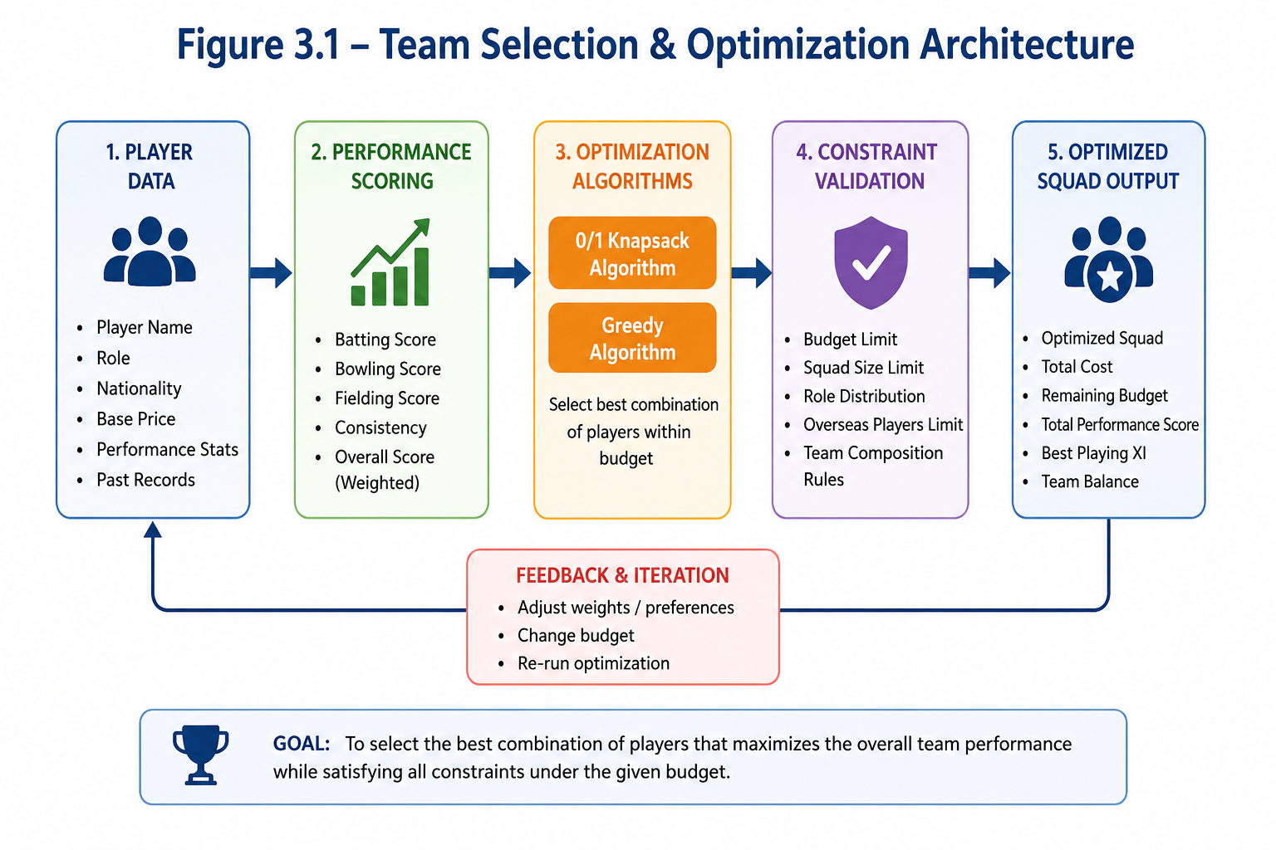
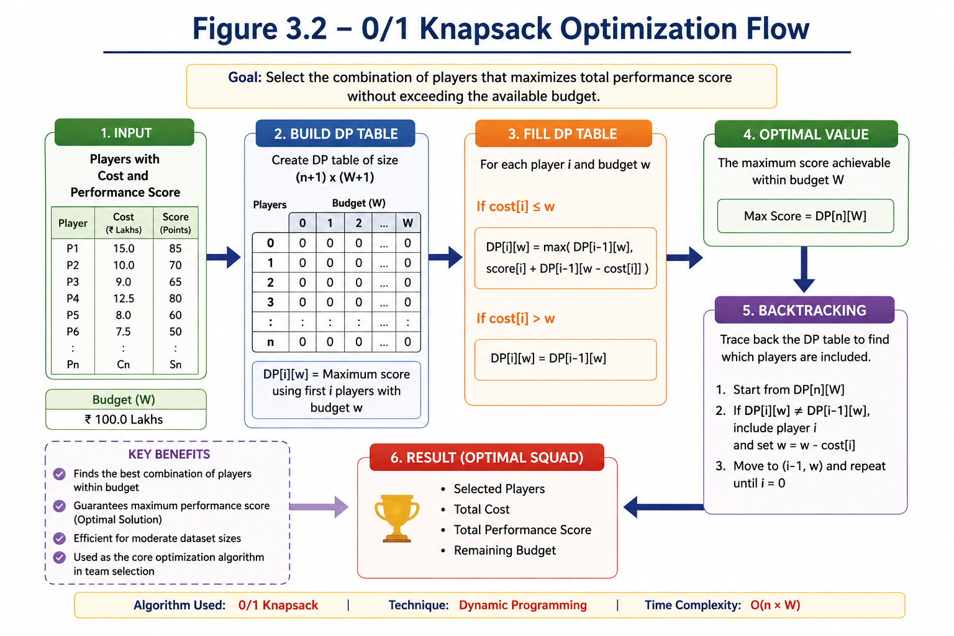
Figure 3.1 – Team Selection & Optimization Architecture
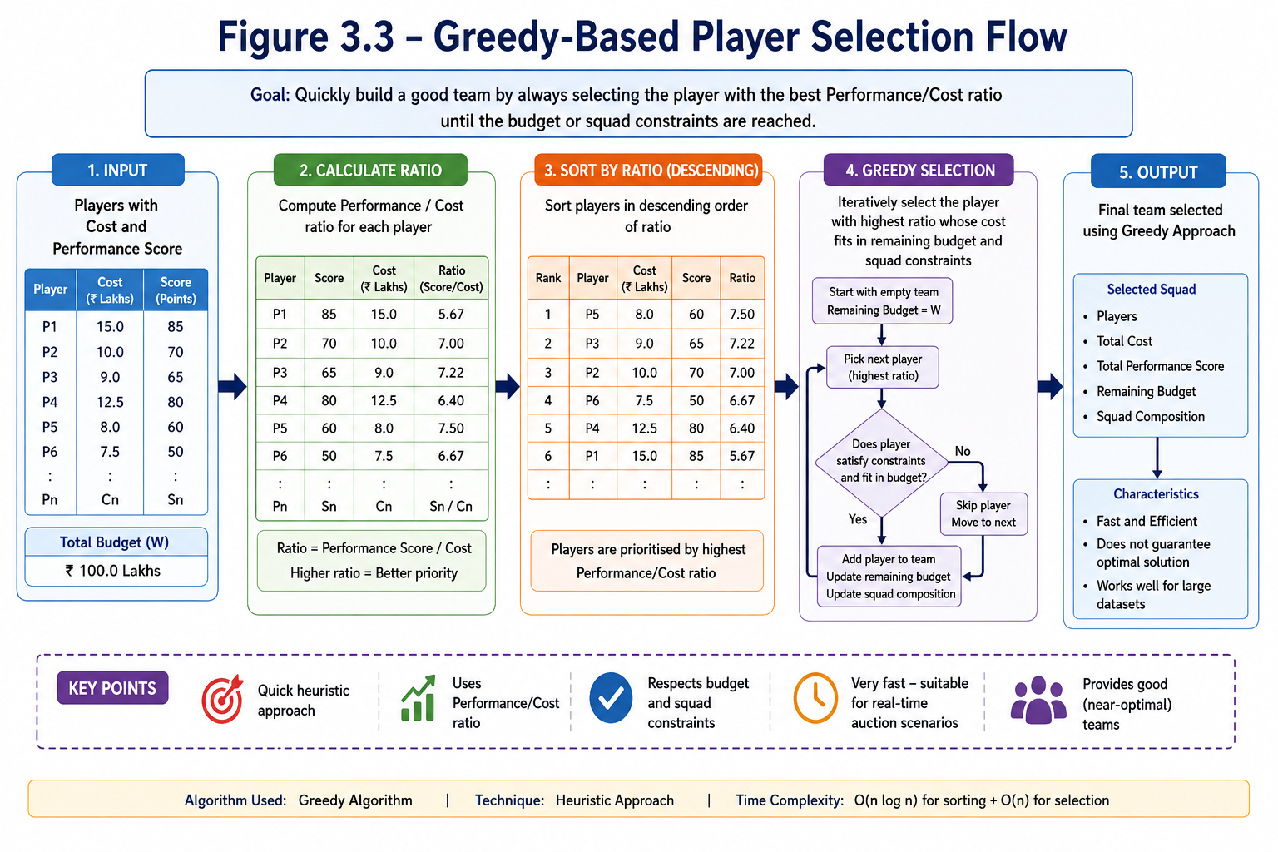
Figure 3.2 – 0/1 Knapsack Optimization Flow
Figure 3.3 – Greedy-Based Player Selection Flow
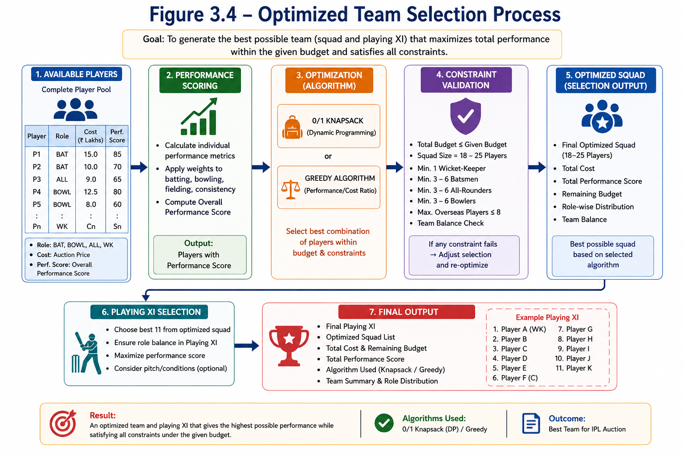
Figure 3.4 – Optimized Team Selection Process
The web-based layered design is selected because it supports real-time interaction while making the DAA concepts visible. The architecture separates the interface, backend services, auction processing, optimization engine, database and analytics.
Layer | Main Responsibility
User / Web Interface | Authentication, dashboards, auction screens and reports.
Flask API Layer | Routes requests, validates input and manages sessions.
Auction Service | Processes bids, purse updates and auction state.
Optimization Engine | Runs 0/1 Knapsack and Greedy team-selection algorithms.
Constraint Validation | Checks budget, squad size, roles and configured rules.
MySQL Database | Stores users, players, teams, bids, squads and analytics.
Analytics Layer | Generates rankings, budget and performance insights.

3.6 Trade-off Analysis
Design Decision | Alternative | Benefit | Disadvantage | Final Decision
0/1 Knapsack | Exhaustive search | Exact optimization for defined budget model | Depends on budget discretization | Selected
Greedy | DP only | Very fast heuristic | Not always globally optimal | Use for comparison
MySQL | Flat files | Structured queries and persistence | Requires DB setup | Selected

3.7 Sustainability, Ethics, Safety, Risk & Security
Domain | Consideration | Evidence | Impact
Sustainability | Use efficient software resources | Software-only prototype | Low infrastructure requirement
Ethics | Use responsible player data | Acknowledged/public or synthetic data | Reduces data concerns
Security | Protect users and auction data | Hashing, sessions, role-based access | Improved protection
Data Integrity | Prevent invalid transactions | Server-side validation and transactions | Consistent results

Risk Register
Risk | Likelihood | Severity | Level | Mitigation | Residual
Invalid bid | Medium | High | High | Server-side bid and budget validation | Low
Budget inconsistency | Medium | High | High | Atomic database updates | Low
Incorrect optimization | Medium | High | High | Known test cases and constraint checks | Low-Medium
Unauthorized access | Low-Medium | High | High | Authentication and role authorization | Low

CHAPTER 4
IMPLEMENTATION, TESTING & RESULTS, PROJECT MANAGEMENT

4.1 Development Approach & Resources
The project follows an incremental development approach. Requirements and auction constraints are defined first, followed by database design and interface implementation. Auction operations are then integrated with the optimization engine, followed by algorithm testing, system testing and analytics validation.
Resource | Purpose
HTML/CSS/JavaScript | Responsive user interface
Bootstrap 5 | UI components and responsive layout
Python Flask | Backend and REST APIs
MySQL | Persistent relational storage
Chart.js | Analytics visualization
VS Code | Development and debugging

4.2 Software Implementation & Modern Tools Used
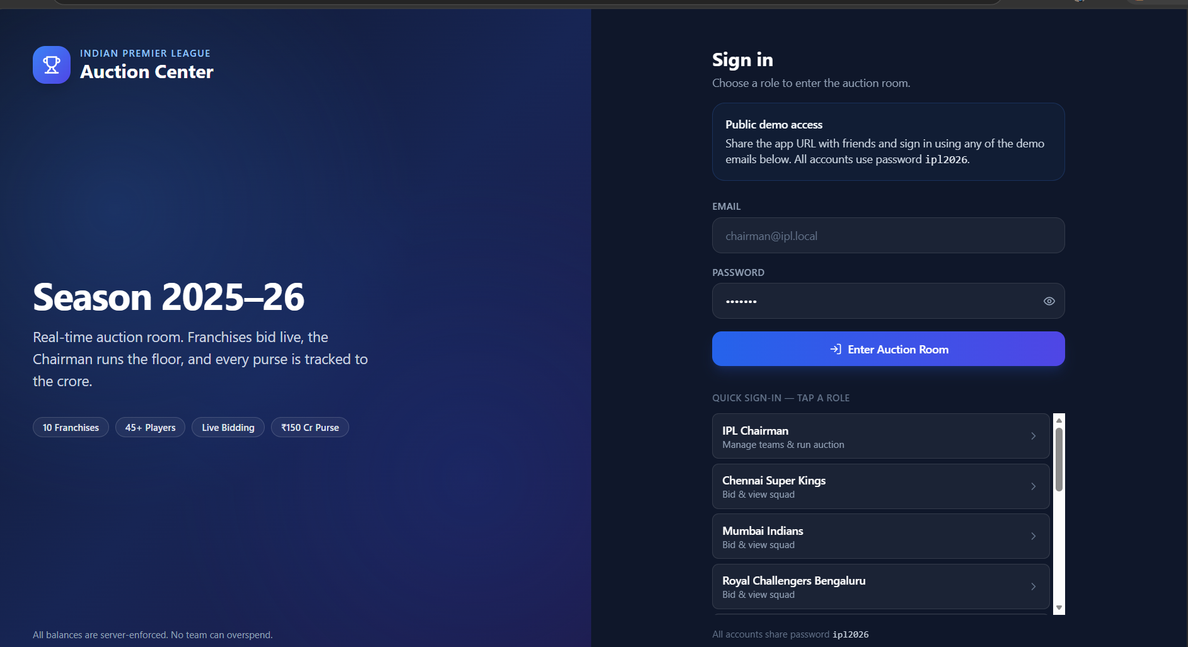
Figure 4.1 – Web Application Dashboard
Tool / Software | Purpose | Stage
Python Flask | Backend and REST API | Implementation
MySQL | Database management | Design/Implementation
Bootstrap 5 | Responsive UI | Frontend
Chart.js | Analytics charts | Frontend/Analytics
Optimization Algorithms | Team selection | DAA Implementation
VS Code | Coding and debugging | All stages

4.2.1 Data Model and File Format
Each player record contains PlayerID, Name, Role, Nationality, BasePrice and performance indicators such as runs, wickets, strike rate and economy. These values are used to derive a performance/value score for optimization.
Example: P001 | Player Name | All-Rounder | Indian | 8.00 Cr | Performance Score 88 | Runs 420 | Wickets 12

4.2.2 Module Implementation

Module | Input | Processing | Output
Player Management | Player details and statistics | Store, validate, search and rank players | Player information
Auction Management | Player, bid and team data | Validate bids and update purse | Auction result and bid history
Team Optimization | Players, costs, scores, constraints | Run Knapsack and Greedy algorithms | Optimized squad and Playing XI

Module 3: Team Selection & Optimization Module

Description

This module is the main DAA component of the project. It selects the best possible IPL team from the available players based on player performance, player cost, team budget, and squad requirements. The module uses optimization algorithms to maximize team performance while satisfying the configured constraints.

Features

Player Selection: Selects suitable players based on performance and price.

Budget Optimization: Ensures the selected squad stays within the available purse.

0/1 Knapsack Algorithm: Finds the best combination of players for maximum performance within the budget.

Greedy Algorithm: Provides a fast player-selection solution based on the performance-to-cost ratio.

Squad Balance: Maintains the required balance between batsmen, bowlers, all-rounders, and wicketkeepers.

Constraint Validation: Checks squad size, budget, and overseas-player limits.

Playing XI Recommendation: Recommends the best Playing XI from the selected squad.

Team Performance Score: Calculates the overall strength of the selected team.

Algorithm Comparison: Compares Greedy and 0/1 Knapsack results based on score, cost, and execution time.

Optimization Report: Displays selected players, total cost, remaining budget, and performance score.

Input

The module takes the following inputs:

Available team budget

Player cost

Player performance score

Player role

Player nationality

Squad requirements

Configured auction constraints

Process

The team selection and optimization process follows these steps:

Player Data → Calculate Performance Score → Apply Optimization Algorithm → Check Budget & Squad Constraints → Select Best Player Combination → Calculate Team Performance → Recommend Best Playing XI

Output

The module produces the following outputs:

Optimized Squad

Total Squad Cost

Remaining Purse

Overall Performance Score

Squad Composition

Best Playing XI

Optimization Algorithm Used

Algorithm Execution Time

Team Recommendation Report

4.3 Test Plan & Verification
Requirement | Test Method | Acceptance Criterion
Login | Valid and invalid credentials | Correct role-based access
Player search | Search by name / role | Relevant players displayed
Bid validation | Bid below/above allowed value | Invalid bid rejected
Budget control | Attempt purchase beyond purse | Transaction rejected
0/1 Knapsack | Known small test dataset | Expected optimum returned
Greedy | Known ranking dataset | Expected heuristic order
Squad constraints | Invalid composition | Constraint violation rejected

Specification | Required Value | Achieved Value | Status
Budget constraint | Never exceed purse | To be measured from final build | Pending evidence
Optimization correctness | Known test optimum | To be measured from final build | Pending evidence
Bid validation | Invalid bids rejected | To be measured from final build | Pending evidence
Authentication | Unauthorized users blocked | To be measured from final build | Pending evidence
Analytics | Correct auction totals | To be measured from final build | Pending evidence

*Update these statuses with actual observed evidence from the final application before submission.

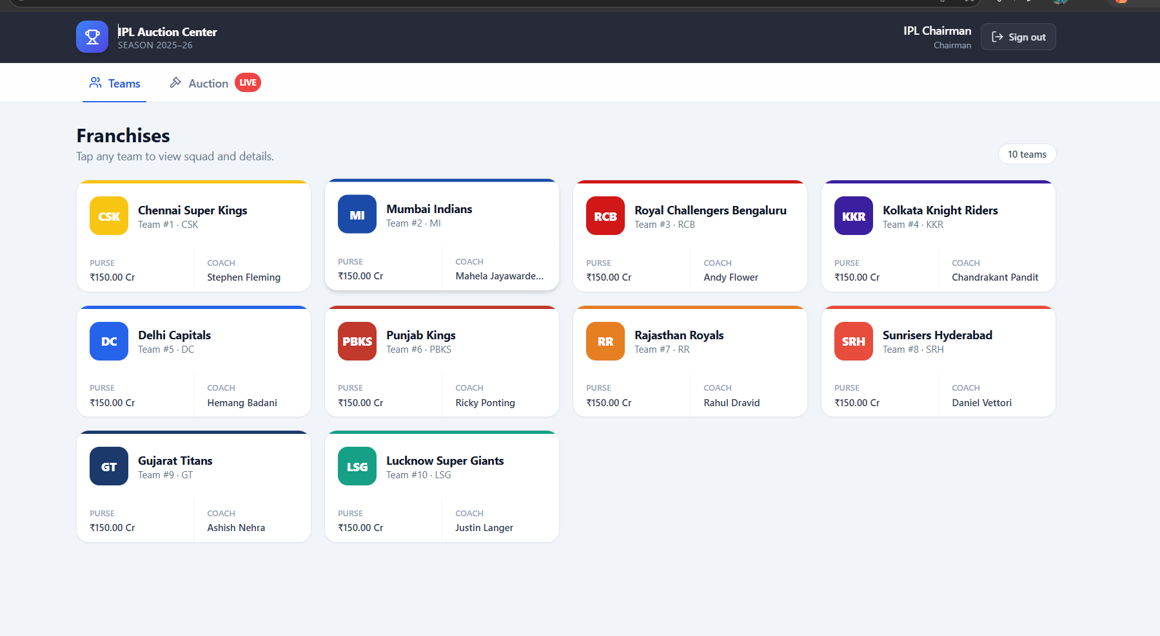
Figure 4.2 – Teams Dash board

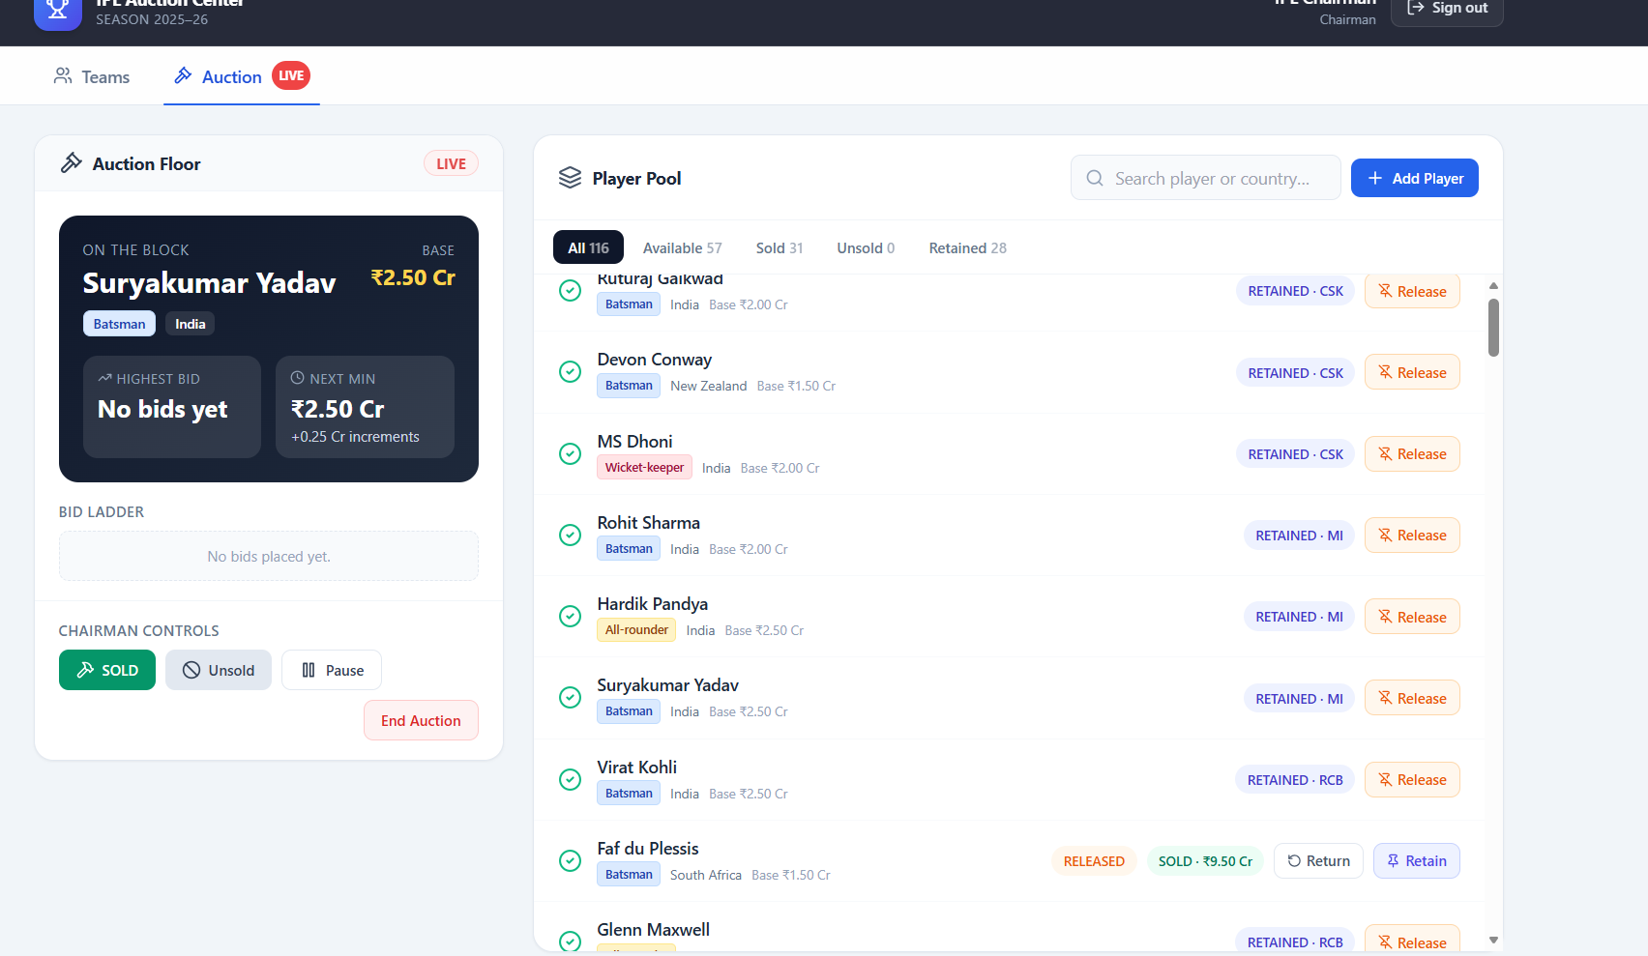
Figure 4.3 – Live Aution
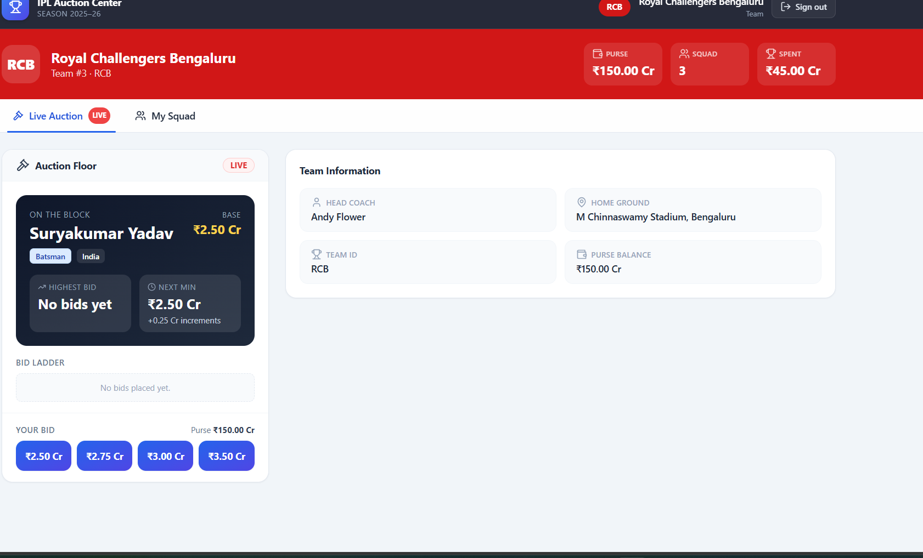
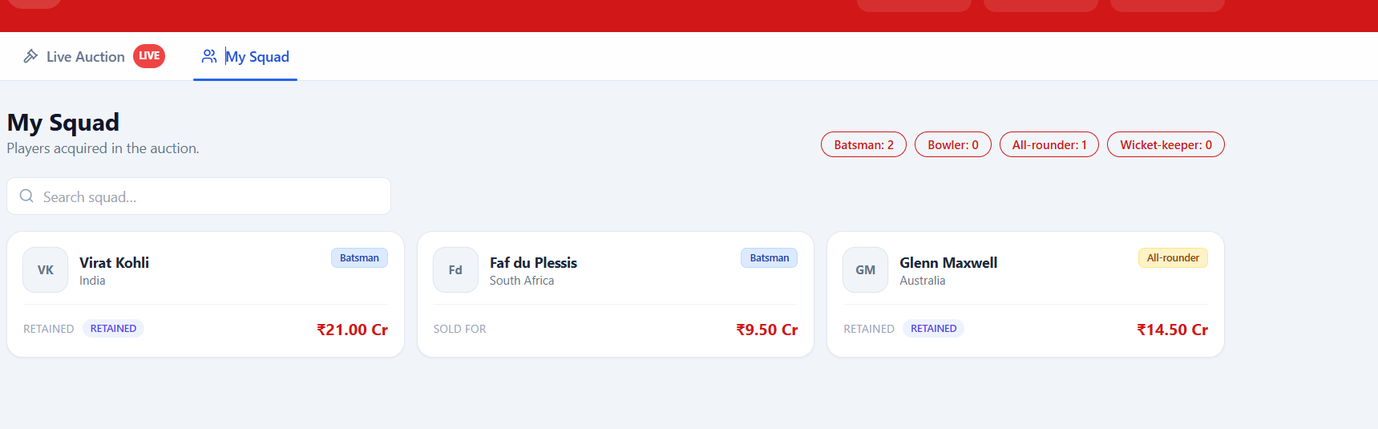 Figure 4.4 – Team Players

4.4 Results
The prototype demonstrates player management, live bidding, budget tracking, team optimization, Playing XI recommendation and analytics. Final execution times, objective values, squad cost and screenshots should be inserted from the running build.

4.5 Data Analysis & Engineering Judgment
The optimization layer is separated from the interface so algorithm correctness and performance can be evaluated independently. The 0/1 Knapsack method provides an exact solution for the defined budget-indexed model, while the Greedy method provides a fast heuristic. For larger multi-objective formulations, more advanced optimization techniques may be considered.

4.6 Comparison with Existing Solutions & Achievement of Objectives

Objective | Evidence | Achievement
Implement optimization | Knapsack + Greedy engine | Implemented / validate final build
Budget-aware team selection | Constraint validation | Implemented / validate final build
Auction management | Bid and purse services | Implemented / validate final build
Analytics | Dashboard and charts | Implemented / validate final build
Testing | Algorithm and system test cases | Planned / validate final build

4.7 Strengths & Limitations
Strengths:
- Simple file-based architecture.
- Clear three-module separation.
- Demonstrates C++ OOP and File Handling.
- No database server required.
- Synthetic data supports privacy in testing.
Limitations:
- Sequential search is less scalable than indexed queries.
- Concurrent multi-user editing is outside scope.
- Advanced authentication is limited.
- Text files provide fewer integrity guarantees than a DBMS.

4.8 Project Planning, Roles & Budget
Milestone | Activity | Status
1 | Requirements and problem definition | Completed
2 | Literature and architecture | Completed
3 | Database and UI implementation | In progress
4 | Auction engine integration | In progress
5 | Optimization implementation | In progress
6 | Testing, report and repository | Planned

Student | Assigned Responsibility | Actual Contribution
Ch. Venkata Ramayogi | Architecture, frontend and integration | To be updated

Item | Estimated Cost | Actual Cost
Existing laptop | Existing resource | Existing resource
Software / IDE | ₹0 | ₹0
MySQL / Flask / Bootstrap | ₹0 | ₹0
GitHub / version control | ₹0 basic use | ₹0
Dataset preparation | ₹0 / academic data | ₹0

CHAPTER 5
CONCLUSION, FUTURE WORK AND REFLECTION

5.1 Conclusion
The IPL Auction Team Selection Using Optimization Algorithms system provides a structured decision-support solution for constrained team selection. It combines player management, auction bidding, budget tracking and analytics with DAA optimization techniques. The 0/1 Knapsack algorithm can identify a high-value combination within a defined budget, while the Greedy algorithm provides a fast heuristic for comparison. Sorting supports player ranking and Priority Queue operations support auction bidding. Overall, the project demonstrates how algorithm design and analysis can be applied to a practical sports-management problem.

5.2 Future Work
- Replace text-file storage with a database for larger datasets.
- Add authentication and role-based access control.
- Add sorting, filtering and duplicate detection.
- Provide automatic backup and restore.
- Add CSV import/export.
- Add cloud deployment and multi-user synchronization.

5.3 Professional Learning & Individual Reflection
New Knowledge Acquired:
- C++ classes, objects, functions and file streams.
- File-based CRUD operations and record rewriting.
- Interface and application integration.
- Validation, testing and backup concepts.
Engineering & Professional Skills Developed:
- Problem formulation and modular design.
- Debugging and functional testing.
- Git/GitHub version control.
- Technical documentation and presentation.
Individual Reflection: The most difficult engineering problem was maintaining consistent records when an existing contact had to be updated or deleted. This was addressed by treating the text file as the persistent source and rebuilding the maintained record set after modification. A key decision was to keep storage file-based because it directly demonstrates the project requirements and avoids unnecessary database infrastructure. If redesigned for production, database storage, authentication, transactions and stronger validation would be added.

REFERENCES
[1] Cormen, T. H., Leiserson, C. E., Rivest, R. L., & Stein, C., Introduction to Algorithms.
[2] Kleinberg, J., & Tardos, É., Algorithm Design, Pearson.
[3] Bellman, R., Dynamic Programming, Princeton University Press.
[4] Malhotra, G. (2022), “A Comprehensive Approach to Predict Auction Prices and Economic Value Creation of Cricketers in the IPL.”
[5] Verma, S., et al. (2022), “A Balanced Squad for Indian Premier League using Modified NSGA-II.”
[6] Dey, P. K., et al. (2024), “Optimising IPL Squad Composition: A Mathematical Framework for Efficient Team Selection.”
[7] Dave, P., & Patel, K. (2025), “A Multi-Objective Optimization Approach to IPL Team Selection using Advanced Performance Metrics and the Real-Binary Algorithm.”
[8] Joglekar, D. J., et al. (2025), “Clustered Auction Strategies and Performance Outcomes in the Indian Premier League.”
[9] Pallets Projects, Flask Documentation.
[10] Oracle, MySQL Documentation.
[11] Chart.js Documentation.
[12] MDN Web Docs, HTML, CSS and JavaScript Documentation.

APPENDICES

Appendix A – Detailed Calculations
No hardware sizing calculations are required for this software-based prototype. Record actual optimization execution time, memory usage where available, dataset size and final test results in the submission.
Appendix B – Engineering Drawings / Schematics
Step | System Flow
1 | User opens the application.
2 | User authenticates and selects the appropriate role.
3 | Player and team data are loaded.
4 | Auction starts and bids are validated.
5 | Winning purchases update the team purse and squad.
6 | Optimization engine evaluates candidate player selections.

Appendix C – Source Code / Code Repository Information
GitHub repository: Add the approved IPL auction project repository URL before final submission.
Complete source code may be maintained in the approved repository; include only essential excerpts in the report.

Appendix D – Dataset Information
The project dataset should contain IPL-style player records including player ID, name, role, nationality, base price and performance indicators. Use a properly acknowledged public dataset or synthetic records for testing.

Appendix E – Experimental / Raw Data
Attach the final CSV/TXT dataset and selected test logs or screenshots here if required.

Appendix F – Ethics / Institutional Approval
No human-subject experiment is proposed. Player data should be sourced responsibly and acknowledged appropriately; synthetic records may be used for algorithm testing.

Appendix G – Project Meeting / Progress Records
Date | Activity | Outcome
21-07-2026 | Requirement discussion | Problem and scope finalized.
30-07-2026 | Architecture review | Four functional areas and optimization approach selected.
20-08-2026 | Implementation review | Core application development reviewed.
25-08-2026 | Testing review | Algorithm and system test plan prepared.
07-09-2026 | Final review | Report and repository prepared.

Appendix J – Individual Contribution Evidence
Ch. Venkata Ramayogi (192424319) – primary contribution included architecture, C++ OOP implementation, Search & Retrieval, Update & Deletion, Report Generation, testing, documentation and repository preparation.

CAPSTONE PROJECT OUTCOME MAPPING SHEET
Outcome Evidence | SO / Area | Location
Complex engineering problem formulation | SO1 | Chapter 1, Sections 1.2–1.3
Engineering design under constraints | SO2 | Chapter 3
Written/oral technical communication | SO3 | Whole report + Viva
Ethics and professional responsibility | SO4 | Chapter 3.7 / Appendix F
Teamwork and leadership | SO5 | Chapter 4.8 / Contribution Statement
Experimentation and engineering judgement | SO6 | Chapter 4.3–4.6
Independent knowledge acquisition | SO7 | Chapter 5.3
Standards | SO2 | Chapter 3.2
Sustainability / societal impact | SO2/SO4 | Chapter 3.7
Risk assessment | SO2/SO4 | Chapter 3.7
Security considerations | Relevant SO | Chapter 3.7
Integrated/system-level engineering | SO1/SO2 | Chapter 3.5
Project planning | SO5 | Chapter 4.8
Individual contribution | SO1–SO7 | Contribution + Chapter 4.8

